P1734: Standard for Electronic Design Intellectual Property (IP) Quality

Abstract: The IP-XACT Standard forms the conformance checks for XML data designed to describe electronic systems. The meta data forms which are standardized include: components, systems, bus interfaces and connections, abstractions of those buses, and details of the components including address maps, register and field descriptions, and file set descriptions for use in automating design, verification, documentation, and use flows for electronic systems. The standard includes a set of XML schemas of the form described by the World Wide Web Consortium (W3C) and a set of semantic consistency rules (SCRs). The standard also provides for a generator interface that is portable across tool environments. The specified combination of methodology-independent metadata and the tool-independent mechanism for accessing that data provides for portability of design data, design methodologies and environment implementations.
Keywords: Electronic Design Automation, EDA, XML Design Meta Data, QIP, XML Schema, Semantic Consistency Rules, SRCs, Design Environment, Use Models, Tool And Data Interoperability, Implementation Constraints, Register Transfer Logic, RTL, Electronic System Level, and ESL.

Introduction
The purpose of this standard is to provide a unified view of quality measures for IP to facilitate the use and integration of this IP used in electronic system design. This will enable the continuous improvement of IP used for system design and verification by providing a mechanism for qualitative comparison between such IP. The standard IP quality measures and characteristic exchange format defined can be incorporated into a variety of EDA tools. The goal of this specification is to specify a quality standard metric that will account for the variances in designing, verifying and testing the IP which will result in fair quality assessment and improved quality, reducing the risk of schedule slip or mask spins due to faulty IP.
The working group consisted of electronic system, IP provider, semiconductor, and EDA companies, and used the VSI Alliance Quality IP (QIP) metric as a baseline for the metrics. The data specified by the standard is extensible in locations specified in the schema. This structure can be used as the basis of both manual and automatic methodologies.
This standardization project provides electronic design and system on chip engineers with a well-defined standard that meets their requirements in evaluating and validating IP and enables a step function increase in their productivity. This standardization project will also provide the EDA industry with a standard to which they can adhere and which they can support in order to deliver their solutions in this area.

Notice to users

Errata
Errata, if any, for this and all other standards of The SPIRIT Consortium can be accessed at the following URL: http://www.spiritconsortium.org/releases/errata/. Users are encouraged to check this URL for errata periodically.

Interpretations
Current interpretations, users guides, examples, etc. can be accessed at the following URL: http://www.spiritconsortium.org/tech/docs/.

Patents
Attention is called to the possibility that implementation of this standard may require use of subject matter covered by patent rights. By publication of this standard, no position is taken with respect to the existence or validity of any patent rights in connection therewith.

Participants
The following members and observers took part in the P1734 Working Group:
Denali: Peter Arnoldy, Alex Zamfirescu
edacentrum: Andreas Voerg
Freescale Semiconductor: Kathy Werner (chair), Michael Rohleder
Hewlett Packard: Mobashar Yazdani
IDT: Camille Kokozaki
Infineon: Ingrid Oesten
Intel: Thad Gardner
Mentor Graphics: Yossi Drori, Bill Martin
RFMD: David Schwan
Rosetta IP: Omri Raisman, Gerardo Nahum
Satin IP: Stephane Bonniol, Michel Tabusse
Synopsys: Zongyao Wen
TI: Asad Khan, Minh Le

Introduction 3
Notice to users 4
1.1.1 Errata 4
1.1.2 Interpretations 4
1.1.3 Patents 4
Participants 5
P1734: Standard for Electronic Design Intellectual Property (IP) Quality 8
2 Overview 8
4.1 Scope 8
4.2 Purpose 8
4.3 Design environment (DE) 8
2.1.1 QIP design environment 8
2.1.2 Design intellectual property 8
4.4 QIP Compliant enabled implementations 9
2.1.3 Design environments 9
4.5 Conventions used 9
2.1.4 Visual cues (meta-syntax) 9
2.1.5 Notational conventions 10
2.1.6 Syntax examples 10
2.1.7 Graphics used to document the schema 10
4.6 Use of color in this standard 11
4.7 Contents of this standard 11
3 Normative references 12
4 Definitions, acronyms, and abbreviations 13
4.8 Definitions 13
4.1.1 design database: 13
4.1.2 design environment (DE): 13
4.1.3 electronic design intellectual property (IP) 13
4.1.4 IP provider: 13
4.1.5 IP repository: 13
4.1.6 meta-data: 13
4.1.7 meta IP: 13
4.1.8 schema: 13
4.1.9 semantic consistency rules (SCRs): 13
4.1.10 use model: 14
4.1.11 user interface: 14
4.1.12 validation: 14
4.1.13 verification: 14
4.1.14 view: 14
4.1.15 verification IP (VIP): 14
4.1.16 Extensible Markup Language (XML): 14
4.1.17 XSLT: 14
4.9 Acronyms and abbreviations 14
5 Interoperability use model 15
4.10 Roles and responsibilities 15
5.1.1 Component IP provider 15
5.1.2 IP design integrator 15
5.1.3 Design tool supplier 15
4.11 IP exchange flows 15
5 QIP schema structure 17
Annex A 18
Semantic consistency rules (SCRs) 18
A.1 Rule listings 18
A.1.1 Questions and numbering 18
A.1.2 Question Handling 18
A.1.3 Hierarchy 19
A.1.4 Usage 19
A.1.5 Scoring 20
A.1.6 Display 20
A.1.7 Vendor Extensions 22

P1734: Standard for Electronic Design Intellectual Property (IP) Quality
- Overview
This clause explains the scope and purpose of this standard; gives an overview of the basic concepts, major semantic components, and conventions used in this standard; and summarizes its contents.

Scope
This standard describes an eXtensible Markup Language (XML)1 data format and structure, documented with a schema for capturing the meta-data which documents design intellectual property (IP) quality metrics used in the development, implementation, verification, and delivery of the IP. The XML documents described and validated by the schema comprise an example method to verify IP that is compatible with automated integration techniques.
Tools compliant with this standard shall be able to read and manipulate IP blocks that comply with the proposed IP meta-data description. This standard is independent of any specific design process.

Purpose
This standard provides a well-defined XML schema for meta-data that documents the characteristics of IP required for the evaluation and measurement of the quality of IP blocks.

Design environment (DE)
The IP-XACT specification is a mechanism to express and exchange information about design IP, it’s development, data management, documentation, verification and validation processes, as well as evaluating the quality and stability of the owning or development organization. While the IP-XACT description formats are the core of this standard, describing the IP-XACT specification in the context of its basic use-model, the design environment (DE), more readily depicts the extent and limitations of the semantic intent of the data. The DE coordinates a set of tools and IP, or expressions of that IP (e.g., models), through the creation and maintenance of meta-data descriptions of the SoC such that its flows are efficiently enabled and re-use centric.

QIP design environment

Design intellectual property
QIP is structured around the concept of IP re-use. Electronic Design Intellectual Property, or IP, is a term used in the electronic design community to refer to a reusable collection of design specifications which represent the behavior, properties, and/or representation of the design in various media. The name IP is partially derived from the common practice of considering a collection of this type to be the intellectual property of one party. Both hardware and software collections are encompassed by this term.
These collections may include the following:
- Design objects—This can include the following
  - Fixed HDL descriptions: Verilog, VHDL
  - Fixed HDL descriptions: Verilog, VHDL
  - Verification IP descriptions: Verilog, VHDL
  - Hardened IP descriptions: GDSII
  - Software descriptions: C, C++, etc
  - HDL-specified verification IP (e.g., basic stimulus generators and checkers)
- IP views—This is a list of different views (levels of description and/or languages) to describe the IP object. QIP v0.1, these views include:
  - Design view: RTL Verilog or VHDL, flat or hierarchical components
  - Simulation view: model views, targets, simulation directives, etc.
  - Documentation view: Standard, User Guide, etc.
  - Supporting scripts: synthesis, makefile, manufacturing test, etc

QIP Compliant enabled implementations
Complying with the rules outlined in this section allows the provider of tools or IP to class their products as QIP Compliant. Conversely, any violation of these rules removes that naming right. This section first introduces the set of metrics for measuring the valid use of the specifications. It then specifies when those validity checks are performed by the various classes of products and providers: DEs, point tools, and IPs.
- Parse validity
- Parsing correctness: Ability to read all QIP descriptions.
- Parsing completeness: Cannot require information which could be expressed in a QIP format to be specified in a non-QIP format. Processing of all information present in a QIP document is not required.
- Description validity
- Schema correctness: Metrics are described using XML files that conform to the QIP schema.
- Usage completeness: Extensions to the QIP schema shall only be used to express information that is not currently described in QIP. This information shall be forwarded to the P1734 committee for potential inclusion in a later release.
- Semantic validity
- Semantic correctness: Adheres to the semantic interpretations of QIP data described in this standard.
- Semantic completeness: Obeys all the semantic consistency rules described in Annex B.
These validity rules can be combined with the product class specific rules to cover the full QIP enabled space. The following subsections describe the rules a provider has to check to claim a tool or DE is QIP Compliant.
A QIP Compliant design environment or point tool may read descriptions based on multiple versions of the QIP schema. If the DE or point tool does provide this capability, the effect shall be as if all of the descriptions had been translated by an XSL Transform (XSLT) which converts descriptions from one version to the next.

Design environments
An IP-XACT Enabled design environment:
- Shall follow the parse validity requirements shown in 1.4.
- When modifying any existing QIP descriptions, shall do so without losing any pre-existing information. In particular, it shall preserve any vendor extension data included in the existing QIP description.

Conventions used
The conventions used throughout the document are included here.
QIP schema is case-sensitive.

Visual cues (meta-syntax)
Bold: shows required keywords and/or special characters, e.g., addressSpace. For the initial definitional use (per element), keywords are shown in boldface-red text, e.g, bitsInLau (see also: 1.6).
Bold italics: shows group names or data types, e.g., nameGroup or boolean. For definitions of types see Annex D.
Courier: shows examples, external command names, directories and files, etc.,
e.g., address 0x0 is on D[31:0]

Notational conventions
The keywords “required”, “shall”, “shall not”, “should”, “should not”, “recommended”, “may”, and “optional” in this document are to be interpreted as described in the IETF Best Practices Document 14, RFC-2119.

Syntax examples
Any syntax examples shown in this Standard are for information only and are only intended to illustrate the use of such syntax

Graphics used to document the schema
http://www.w3.org/TR/2004/REC-xmlschema-1-20041028/ specifies the XML schema language used to define the QIP XML schemas. Normative details for compliance to the QIP standard are contained in the schema files. Within this document, pictorial representations of the information in the schema files illustrate the structure of the schema and define any constraints of the standard. With the exception of scope and visibility issues, the information in the figures and the schema files is intended to be identical. Where the figures and schema are in conflict, the XML schema file shall take precedence

Elements and attributes
The element is the fundamental building block on which this standard is based. An element may be either a leaf element, which is a container for information, or a branch element, which may contain further branch elements or leaf elements.
A leaf or branch element may also contain attributes. Attributes are containers for information within the containing element.

Types
A type is a designation of the format for the contents of an element or attribute. There are two different styles of types that can be defined. A type may be assigned to a leaf element or an attribute. This type is called a simpleType and defines the format of data that may be stored in this container. A type may also be assigned to a branch element. This type is called a complexType and defines further elements and attributes contained in the branch element.

Groups
A group is a collection of elements or attributes, which allow the same collection of items to be referenced consistently in many places. There are two different types of groups that can be defined. A group is a combination of leaf or branch elements. An attributeGroup, a simple list f attributes. The names assigned to either group have no representation in the resulting description.

Name space
Each element, attribute, type, or group has a name, which is preceded by a namespace and separated from the name by a colon (:). For the examples in 1.5.4.5, xyz is used as the namespace for all of the items whereas the Standard uses spirit. Within the text of this standard, the namespace is not written when describing an item; it is only shown in examples.

Diagrams
The diagrams used throughout this standard graphically detail the organization the elements and attributes.

Use of color in this standard
This standard uses a minimal amount of color to enhance readability. The coloring is not essential and does not affect the accuracy of this standard when viewed in pure black and white. The places where color is used are the following:
-- Cross references that are hyperlinked to other portions of this standard are shown in underlined-blue text (hyperlinking works when this standard is viewed interactively as a PDF file).
-- Syntactic keywords and tokens in the formal language definitions are shown in boldface-red text.

Contents of this standard
The organization of the remainder of this standard is as follows:
-- Clause 2 provides …
-- Clause 3 provides …
- Normative references
The following referenced documents are indispensable for the application of this document. For dated references, only the edition cited applies. For undated references, the latest edition of the referenced document (including any amendments or corrigenda) applies.
The Simple Object Access Protocol (SOAP) Version 1.2 specification is available from the W3C web site: http://www.w3.org/TR/2007/REC-soap12-part1-20070427/.
The Web Services Description Language (WSDL) 1.1 specification is available from the W3C web site: http://www.w3.org/TR/wsdl.
The XML version 1.0 is available from the W3C web site:
http://www.w3.org/TR/2000/REC-xml-20001006.
The XML Schema specification is available from the W3C web site:
http://www.w3.org/TR/2004/REC-xmlschema-0-20041028;
http://www.w3.org/TR/2004/REC-xmlschema-1-20041028;
http://www.w3.org/TR/2004/PER-xmlschema-2-20040318.
- Definitions, acronyms, and abbreviations
For the purposes of this document, the following terms and definitions apply. The Authoritative Dictionary
of IEEE Standards Terms [B2]8 should be referenced for terms not defined in this clause.

Definitions

design database:
Working storage for both meta-data and component information that helps create and verify systems and subsystems.

design environment (DE):
The coordination of a set of tools and IP, or expressions of that IP (e.g., models) so the system-design and implementation flows of a SoC re-use-centric development flow is efficiently enabled. This is managed by creating and maintaining a meta-data description of the SoC.

electronic design intellectual property (IP)
is a term used in the electronic design community to refer to a reusable collection of design specifications which represent the behavior, properties, and/or representation of the design in various media. The name IP is partially derived from the common practice of considering a collection of this type to be the intellectual property of one party. Both hardware and software collections are encompassed by this term. IP utilized in the context of a SoC design or design flow may include specifications; design models; design implementation descriptions; verification coordinators, stimulus generators, checkers and assertion / constraint descriptions; soft design objects (such as embedded software and real-time operating systems); design and verification flow information and scripts. IP-XACT distinguishes between fixed IP and configurable IP.

IP provider:
Creator and supplier of IP.

IP repository:
Database of IP.

meta-data:
A tool-interpretable way of describing the design-history, locality, object association, configuration options, constraints against, and integration requirements of an object.

meta IP:
Meta-data description of an object.

schema:
A means for defining the structure, content, and semantics of Extensible Markup Language (XML) documents

semantic consistency rules (SCRs):
Additional rules applied to an XML description that cannot be expressed in the schema. Typically, these are rules between elements in multiple XML descriptions.

use model:
A process method of working with a tool.

user interface:
Methods of interacting between a tool and its user.

validation:
Proving the correctness of construction of a set of components.

verification:
Proving the behavior of a set of connected components.

view:
An implementation of a component. A component may have multiple views, each with it's own function in the design flow.

verification IP (VIP):
Components included in a design for verification purposes.

Extensible Markup Language (XML):
A simple, very flexible text format derived from SGML (see ISO/IEC 8879).

XSLT:
XSL Transform is a particular program written in the XSL language for performing a transformation (from one version to the next).

Acronyms and abbreviations
DE design environment
EDA electronic design automation
HDL hardware description language
IP electronic design intellectual property
RTL register transfer level (design)
SCR semantic consistency rule
SoC system on chip
VIP verification IP
XSLT XSL Transform
XML Extensible Markup Language
- Interoperability use model
To introduce the use-model for the QIP metric, it is first necessary to identify specific roles and responsibilities within the model, and then relate these to how the QIP metric impact their interactions. All or some of the roles can be mixed within a single organization, e.g., some EDA providers are also providing IP, a component IP provider can also be a platform provider, and an IP system design provider may also be a consumer.

Roles and responsibilities
For this Standard, the roles and responsibilities are restricted to the scope of QIP v0.1.

Component IP provider
This is a person, group or company creating IP components or subsystems for integration into a SoC design. These IPs can be hardware components (processors, memories, buses, etc.), verification components, and/or hardware-dependent software elements. They may be provided as source files or in a compiled or hardened form (i.e., simulation model or GDSII). An IP is usually provided with a functional description, a timing description, documentation, some implementation or verification constraints and/or scripts, and some parameters to characterize (or configure) the IP. All these types of characterization data may be evaluated as meta-data compliant with the QIP Metric.
The IP provider can use one or more EDA tools to create/refine/debug IP. At some point, this IP can be transferred to customers, partners and external EDA tool suppliers along with the QIP metric XML data.

IP design integrator
This is a person, group or company that integrates and validates IP provided by one or more IP providers to build system platforms, which are complete and validated systems or sub-systems. Like the IP provider, the platform provider can use EDA tools to create/refine/debug its platform,…………………………

Design tool supplier
This is a group or company that provides tools to verify an IP or platform IP. There are xx major tools (which could be combined, required in the flow:
- schema validator
- file parser
- metric calculator

IP exchange flows
This section describes a typical IP exchange flow that the QIP metric technically supports between the roles defined in 4.1. By way of example, the following specific exchange flow can benefit from use of the IP-XACT specification.
The Component IP provider generates a QIP XML package and sends it to a SoC design-tool (EDA tool supplier) or directly to a Platform (i.e., SoC Design IP) provider. The EDA tool supplier imports IP-XACT XML IP and generates platform IP and/or updates (configures) the IP components. The Platform provider generates a configurable platform IP and exports it in IP-XACT XML format, which the end-user imports to build system applications. The platform provider can also generate its own platform IP into IP-XACT format and send it to the EDA provider.
Although many different possible IP exchange flows exist, from the user’s viewpoint, there are three main use models:
— IP (Component or SoC Design) provider use model
— Generator (IP provider and Design tool provider) use model
— SoC design-tool provider use model

The tool initializes and or updates the list of IP quality checks in its internal database by reading the golden XML file with its IEEE schema for validation.

The tool provides features for the assessment of the IP quality checks and for metric calculation.

The tool exports assessment result to an Answer XML file, compliant with the IEEE schema.

The tool imports assessment result from an Answer XML files with its IEEE schema for validation, and initializes or updates the assessments of the IP quality checks in its internal database.
QIP schema structure for the golden XML

This first schema of the QIP specification is used to describe the golden IP quality checks provided by the standard. The element qipReference is the top level element of this schema.

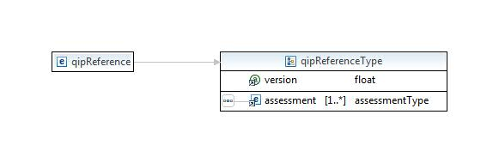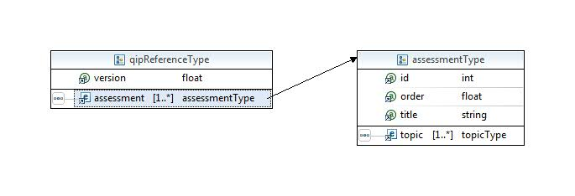

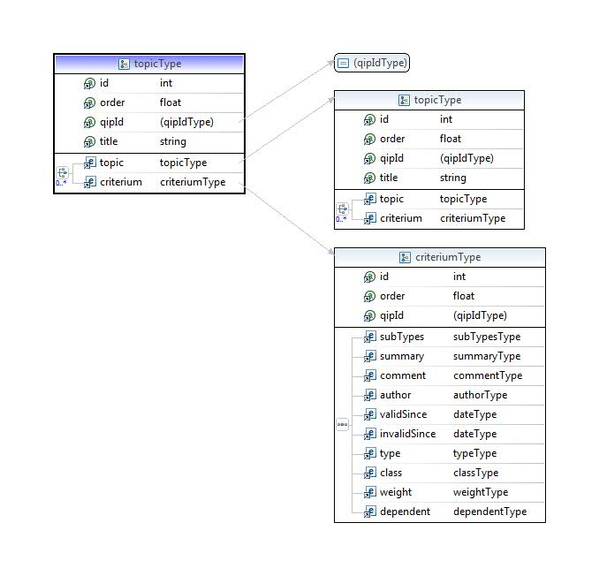

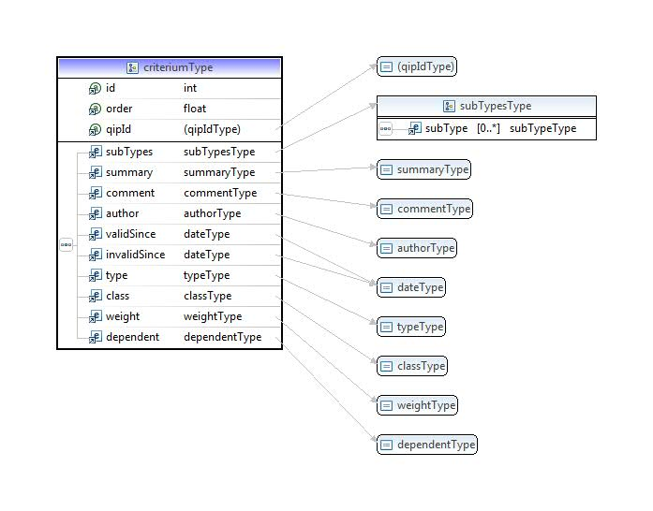
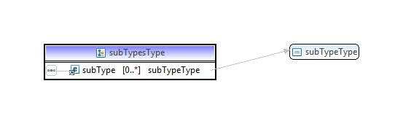

Description

The top level element qipReference has an attribute version which specifies the version number of the golden XML file. This version number is used to keep a common reference between the different XML files: golden, answer XML files.

The top level element qipReference contains 1 or multiple elements assessment.

The element assessment represents the set of quality checks used for a given type of quality assessment: Vendor, Soft IP Integration, Soft IP Development, Hard IP Integration, Hard IP Development, Verification IP, Software IP. It has 3 attributes:
- The attribute id is unique and is used to strictly identify the assessment
- The attribute order is used to specify the sequence order of different assessments. The tool uses this attribute to display in a GUI the list of assessments in a coherent order
- The attribute qipId is the reference id of the IEEE QIP database

The element assessment contains 1 or multiple elements topic.

The element topic represents the set of quality metrics used for a given type of area of concerns. It has 4 attributes:
- The attribute id is unique and is used to strictly identify the topic
- The attribute order is used to specify the sequence order of different topics. The tool uses this attribute to display in a GUI the list of topics in a coherent order
- The attribute qipId is the reference id in the IEEE QIP database
- The attribute title is used to specify the title of the topic. The tool uses this attribute to display the title of the topic in a GUI.

The element topic contains 0 or multiple elements topic and 0 or multiple elements criterium.

The element criterium represents a Quality Check item. It has 3 attributes:
- The attribute id is unique and is used to strictly identify the criterium
- The attribute order is used to specify the sequence order of different criteria. The tool uses this attribute to display in a GUI the list of criteria in a coherent order
- The attribute qipId is the reference id in the IEEE QIP database

The element criterium contains the following elements:

- The element subTypes specifies the list of IP subtypes this criterium is relevant for. If left empty, it means that the criterium is valid for any subtype. The expected values for the subtype are: Digital, Analog/AMS, I/O and ESD, Memory, MEMS, DupEnabled. The tool uses this attribute to select the appropriate list of criterium for assessment.
- The element summary contains the text in natural language, subject of the criterium. The tool uses this attribute to display the subject text of the criterium in a GUI
- The element comment contains an additional text in natural language for extra comment. The tool uses this attribute to display comment text of the criterium in a GUI
- The element author contains the name of the Quality Check item creator. The tool uses this attribute to display the author of the criterium in a GUI
- The element validSince specifies the start date validity of the criterium. The tool uses this attribute to check the validity of the criterium
- The element invalidSince specifies the end date validity of the criterium. The tool uses this attribute to check the validity of the criterium
- The element type specifies the type of expected answers to the criterium; there are two kinds of answers: a/o/n (a/o/n, Always, Often, Never) or y/n (y/n, y, n). The tool uses this attribute to propose the possible answer values for the assessment of the criterium
- The element class specifies the class of the criterium; there are four classes: Imperative, Rule, Guideline, or Optional. The tool uses this attribute to classify the criterium
- The element weight specifies the integer score of the criterium when satisfied. The tool uses this attribute for scoring and consolidation
- The element dependent specifies the integer id of another criterium from which the current criterium depends. If the referenced criterium is not satisfied then the current criterium is not relevant. The tool uses this attribute to identify the parent of the criterium

Example

The example below shows the first lines of a golden XML listing the standard quality checks for a Hard IP Development purpose:

<?xml version="1.0" encoding="ISO-8859-1"?>

<ieee_p1734:qipReference ieee_p1734:version="0.1" xmlns:ieee_p1734="https://secure.edacentrum.de/standardisierung/qip" xmlns:xs="http://www.w3.org/2001/XMLSchema" xmlns:xsi="http://www.w3.org/2001/XMLSchema-instance" xsi:schemaLocation="https://secure.edacentrum.de/standardisierung/qip https://secure.edacentrum.de/standardisierung/qip/qip_golden.xsd">

<!-- assessmentId=5 -->

<ieee_p1734:assessment ieee_p1734:id="5" ieee_p1734:order="1" ieee_p1734:title="Hard IP Development">

<ieee_p1734:topic ieee_p1734:id="101" ieee_p1734:order="1" ieee_p1734:qipId="1" ieee_p1734:title="IP Ease of Reuse">

<ieee_p1734:topic ieee_p1734:id="102" ieee_p1734:order="2" ieee_p1734:qipId="1.1" ieee_p1734:title="Ease of Integration">

<ieee_p1734:topic ieee_p1734:id="103" ieee_p1734:order="3" ieee_p1734:qipId="1.1.1" ieee_p1734:title="Configurability and Parameterization">

<ieee_p1734:criterium ieee_p1734:id="467" ieee_p1734:order="1" ieee_p1734:qipId="1.1.1.1">

<ieee_p1734:subTypes>

<ieee_p1734:subType>Digital</ieee_p1734:subType>

<ieee_p1734:subType>Analog/AMS</ieee_p1734:subType>

<ieee_p1734:subType>Memory</ieee_p1734:subType>

</ieee_p1734:subTypes>

<ieee_p1734:summary>Is the IP configurable?</ieee_p1734:summary>

<ieee_p1734:comment/>

<ieee_p1734:author>IEEE P1734 QIP Working Group</ieee_p1734:author>

<ieee_p1734:validSince>2008-04-19 00:00:00</ieee_p1734:validSince>

<ieee_p1734:invalidSince/>

<ieee_p1734:type>y/n</ieee_p1734:type>

<ieee_p1734:class>Rule</ieee_p1734:class>

<ieee_p1734:weight>5</ieee_p1734:weight>

<ieee_p1734:dependent/>

</ieee_p1734:criterium>

<ieee_p1734:criterium ieee_p1734:id="468" ieee_p1734:order="2" ieee_p1734:qipId="1.1.1.2">

<ieee_p1734:subTypes>

<ieee_p1734:subType>Digital</ieee_p1734:subType>

<ieee_p1734:subType>Memory</ieee_p1734:subType>

</ieee_p1734:subTypes>

<ieee_p1734:summary>Is the IP designed to support instance by instance configurability?</ieee_p1734:summary>

<ieee_p1734:comment/>

<ieee_p1734:author>IEEE P1734 QIP Working Group</ieee_p1734:author>

<ieee_p1734:validSince>2008-04-19 00:00:00</ieee_p1734:validSince>

<ieee_p1734:invalidSince/>

<ieee_p1734:type>y/n</ieee_p1734:type>

<ieee_p1734:class>Rule</ieee_p1734:class>

<ieee_p1734:weight>5</ieee_p1734:weight>

<ieee_p1734:dependent/>

</ieee_p1734:criterium>

<ieee_p1734:criterium ieee_p1734:id="469" ieee_p1734:order="3" ieee_p1734:qipId="1.1.1.3">

<ieee_p1734:subTypes>

<ieee_p1734:subType>Digital</ieee_p1734:subType>

<ieee_p1734:subType>Analog/AMS</ieee_p1734:subType>

</ieee_p1734:subTypes>

<ieee_p1734:summary>Can you change the parametrics through pin programmability?</ieee_p1734:summary>

<ieee_p1734:comment/>

<ieee_p1734:author>IEEE P1734 QIP Working Group</ieee_p1734:author>

<ieee_p1734:validSince>2008-04-19 00:00:00</ieee_p1734:validSince>

<ieee_p1734:invalidSince/>

<ieee_p1734:type>y/n</ieee_p1734:type>

<ieee_p1734:class>Rule</ieee_p1734:class>

<ieee_p1734:weight>5</ieee_p1734:weight>

<ieee_p1734:dependent/>

</ieee_p1734:criterium>

</ieee_p1734:topic>

QIP schema structure for the answer XML

This second schema of the QIP specification is used to describe the answers to the IP quality metrics. The element qipAnswer is the top level element of this schema.

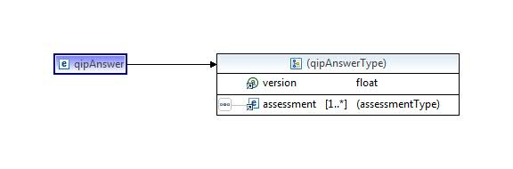
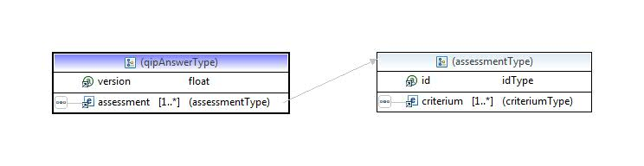
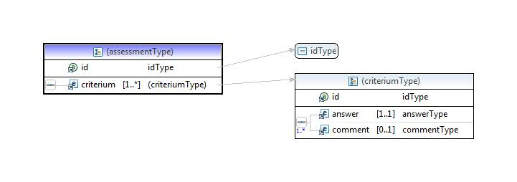

Description

The top level element qipAnswer has an attribute version which specifies the version number of the golden XML file. This version number is used to keep a common reference between the different XML files: golden, answer XML files.

The top level element qipAnswer contains 1 or multiple elements assessment.

The element assessment represents the set of quality metrics used for a given type of quality assessment: Vendor, Soft IP Integration, Soft IP Development, Hard IP Integration, Hard IP Development, Verification IP, Software IP. It has 1 attribute:
- The attribute id is unique and is used to strictly identify the assessment

The element assessment contains 1 or multiple elements criterium.

The element criterium represents a Quality Check item. It has 1 attribute:
- The attribute id is unique and is used to strictly identify the criterium.

The element criterium contains the following elements:
- The element answer contains answer to the criteria. The expected values for the answer are: a/o/n, Always, Often, Never, y/n, y, n. The tool uses this attribute to write or read the answer of the criterium
- The element comment contains a text in natural language for comment. The tool uses this attribute to write or read the comment of the criterium

Example

The example below shows the first lines of an answer XML for the Hard IP Development quality checks:

<?xml version="1.0" encoding="UTF-8"?>

<ieee_p1734:qipAnswer xmlns:ieee_p1734="https://secure.edacentrum.de/standardisierung/qip" xmlns:xs="http://www.w3.org/2001/XMLSchema" xmlns:xsi="http://www.w3.org/2001/XMLSchema-instance" xsi:schemaLocation="https://secure.edacentrum.de/standardisierung/qip https://secure.edacentrum.de/standardisierung/qip/qip_answer.xsd">

<ieee_p1734:assessment ieee_p1734:id="5">

<ieee_p1734:criterium ieee_p1734:id="467">

<ieee_p1734:answer>n</ieee_p1734:answer>

<ieee_p1734:comment></ieee_p1734:comment>

</ieee_p1734:criterium>

<ieee_p1734:criterium ieee_p1734:id="469">

<ieee_p1734:answer>y/n</ieee_p1734:answer>

<ieee_p1734:comment></ieee_p1734:comment>

</ieee_p1734:criterium>

<ieee_p1734:criterium ieee_p1734:id="471">

<ieee_p1734:answer>y</ieee_p1734:answer>

<ieee_p1734:comment></ieee_p1734:comment>

</ieee_p1734:criterium>

<ieee_p1734:criterium ieee_p1734:id="472">

<ieee_p1734:answer>y</ieee_p1734:answer>

<ieee_p1734:comment></ieee_p1734:comment>

</ieee_p1734:criterium>

<ieee_p1734:criterium ieee_p1734:id="474">

<ieee_p1734:answer>y</ieee_p1734:answer>

<ieee_p1734:comment></ieee_p1734:comment>

</ieee_p1734:criterium>

<ieee_p1734:criterium ieee_p1734:id="475">

<ieee_p1734:answer>y</ieee_p1734:answer>

<ieee_p1734:comment></ieee_p1734:comment>

</ieee_p1734:criterium>

<ieee_p1734:criterium ieee_p1734:id="476">

<ieee_p1734:answer>y</ieee_p1734:answer>

<ieee_p1734:comment></ieee_p1734:comment>

</ieee_p1734:criterium>

Annex A

Semantic consistency rules (SCRs)
For an QIP document or a set of QIP documents, to be valid they shall, in addition to conforming to the QIP schema, obey certain semantic rules. While many of these are described informally in other sections of this document, this chapter defines them formally. Tools generating QIP documents shall ensure these rules are obeyed. Tools reading QIP documents shall report any breaches of these rules to the user.

Rule listings
Most of the semantic rules listed here can be checked purely by manually examining a set of IP-XACT documents.

Questions and numbering

- Questions and numbering
Rule Number | Rule | Single Doc Check | Notes
 | Question text cannot be changed
 | Each question has a unique numerical identifier
 | If a question is retired, the numerical identifier is also retired
 | If a question is added, a new unique numerical identifier is also added and associated with the question
 | Questions shall be grouped by topical areas
 | The topical areas shall form the basis of the numbering scheme
 | Up to three sub-areas may be used for each top level topical area
 | The highest level topical area shall be for the type of assessment |  | Vendor Assessment  Soft IP Integration  Soft IP Development  Hard IP Integration  Hard IP Development  Verification IP  Software IP

Question Handling

- Question Handling
Rule Number | Rule | Single Doc Check | Notes
 | Questions shall be classified as Imperative, Rule, Guideline, Optional, Mitigable
 | Optional questions when answered “y”, will enable the subsequent detailed questions that are dependent on the optional question
 | Optional questions when answered “n”, will disable the subsequent detailed questions that are dependent on the optional questio
 | Optional questions when answered “n”, the subsequent detailed questions shall be removed from the completion and scoring metrics
 | Legal question answer options cannot be changed
 | Questions shall be quantitative and answerable by yes or no (“y” or “n”). |  | When unavoidable, always / often / never (“a” or “o” or “n”) may be used

Hierarchy

- Hierarchy
Rule Number | Rule | Single Doc Check | Notes
 | The top-level of hierarchy is the View
 | Next down is the Area of Concern
 | Below the Areas of Concern may be Topics
 | Beneath the lowest applicable hierarchical category are questions
 | All questions and their Topic header row are grouped together so that it is possible to collapse the display to just the header row.
 | All Topics and their Area of Concern header row are grouped together so that it is possible to collapse the display to just the header row
 | All Areas of Concern and their View header rows are grouped together so that it is possible to collapse the display to just the header row

Usage

- Usage
Rule Number | Rule | Single Doc Check | Notes
 | IP Providers, or those completing the metric, may not change any question classification, weight or legal answer
 | IP Users, or those evaluating the metric, may change only the classification (imperative, rule, etc) of the questions to customize for their applications

Scoring

- Scoring
Rule Number | Rule | Single Doc Check | Notes
 | Questions grouped by topical areas and corresponding Question scores shall roll up into Topical scoring.
 | Topical scoring shall roll up into Overall score for the IP.
 | Imperatives shall be assigned a weight of 10 points |  | y = 10pt, n=0pt
 | Rules shall be assigned a weight of 5 points |  | y=5pt, n=0pt
 | Guidelines shall be assigned a weight of 2 points |  | y=2pt, n=0pt
 | Optional questions have no weight
 | Section scoring (Topical or Overall) is equal to the % of points obtained out of the total possible points possible for questions answered
 | QIP does not give pass or fail grade. Only the IP User can make that decision |  | QIP is a tool to help to objectively contrast alternatives and make an informed decision

Display

- Display
Rule Number | Rule | Single Doc Check | Notes
 | Overall score summary table lists IP overall score (% of pts scored out of total possible).
 | Overall score summary table lists the number of questions answered unsatisfactorily as a "Traffic Light" visual |  | The Imperatives, marked in red for "Danger," are the most important questions. (At a minimum, if this were a real product, you would want all Imperative questions satisfied.) The Rules and Guidelines that were not satisfied, which are marked in orange/yellow for "Caution," are of lesser importance. Questions that received satisfactory answers are marked in green for "Go."
 | Topical summary table separately displayed for each high level area |  | Vendor Assessment, Soft IP Integration, Soft IP Development, Hard IP Integration, Hard IP Development, Verification IP, Software IP
 | Topical summary table will list the Topical area score |  | (% of pts scored out of total possible
 | Topical summary table lists the number of questions from Topical area answered unsatisfactorily as a "Traffic Light" visual |  | The Imperatives, marked in red for "Danger," are the most important questions The Rules and Guidelines that were not satisfied, which are marked in orange/yellow for "Caution," are of lesser importance. Questions that received satisfactory answers are marked in green for "Go."
 | Topical summary table should have ability to drill down to individual questions contained in the topical area |  | Question details should show question, assessment, score, comments, and question importance (Imperative, Rule, Guideline, or Optional) for each question. Based on question response, the question score will have Traffic light color coding: Red = Danger = An imperative not being met (i.e. an “n” answer), Orange/Yellow = Caution = A Rule or Guideline not being met (i.e. an “n” answer), Green= Go = Question answered satisfactory.

Vendor Extensions

- Vendor Extensions
Rule Number | Rule | Single Doc Check | Notes

