Minutes: IEEE-SA P1666.1 SystemC AMS extensions Working Group meeting
Date & Time: November 16, 2015, 17:00 CEST
Minutes taken by Martin Barnasconi

Attendees:
Martin Barnasconi, NXP Semiconductors
Joe Daniels, Accellera Systems Initiative
Karsten Einwich, COSEDA Technologies
Sumit Adhikari, NXP Semiconductors
Olivier Guillaume, STMicroelectronics
Thilo Voertler, Fraunhofer IIS/EAS

Agenda
- Call to order
- Roll call
- IEEE-SA patent policy and call for patents
- Approval of agenda
- Approval of previous minutes October 5, 2015
- Results of IEEE Sponsor ballot
- Status of IEEE public review
- AOB
- Next meeting
- Adjournment

1. Call to order
Martin opens the meeting at 17.00 CET and welcomes the participants.
2.Roll call
Attendance tracking till before the meeting
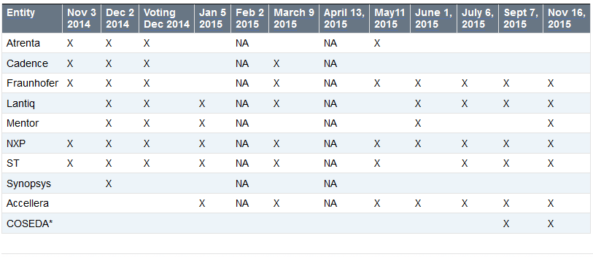
- Entities represented today: NXP, COSEDA Tech (non vote), Accellera, ST, Fraunhofer.
- Entities with voting rights (attended two of the last three meetings): NXP, Fraunhofer, Accellera, Lantiq, ST
- 4 of 5 eligible voting entities represented. Quorum achieved.
3. IEEE-SA patent policy and call for patents
- Martin presents a slides 1-4 of the IEEE patent policy. More information in
http://standards.ieee.org/board/pat/pat-slideset.pdf
- Please study the IEEE-SA patent policy and patent related links:
  - IEEE-SA Standards Boards Bylaws: http://standards.ieee.org/develop/policies/bylaws/sect6-7.html#6
  - IEEE-SA Standards Board Operations Manual: http://standards.ieee.org/develop/policies/opman/sect6.html#6.3
  - Material about the patent policy: http://standards.ieee.org/about/sasb/patcom/materials.html
Call for Potentially Essential Patents
None of the participants is personally aware of the holder of any patent claims that are potentially essential to implementation of the SystemC AMS standard.

4. Approval of the agenda
Motion to approve the agenda.
Motion to approve: Joe; Second: Thilo. Agenda approved.

5. Approval of previous meeting minutes
Minutes can be found here: http://www.eda.org/twiki/pub/P16661/October5%2c2015/p16661_minutes_2015_10_05.docx
Minor edit requested: in AOB, November 16 should be November 2.
Motion to approve with the above edit incorporated: Joe; Second: Olivier. Minutes approved.
6. Results of IEEE Sponsor ballot
- Ballot passed:
- 15 comments received. Excel file available with comments:
http://www.eda.org/twiki/pub/P16661/MemberArea/p16661_ballot_comments.xlsx
- Next step: update LRM to resolve comments
  - Create version D5
  - Start re-circulation Ballot?
- Discussion:
  - Martin will update the document and create version D5
  - Current changes are accepted. Highlights will only show differences between D4 and D5
  - WG will ratify the D5 version in the next meeting (December 7)
  - Recirculation ballot is initiated after ratification, preferably December 7
  - Submission to RevCom is planned directly after ratification in the WG.
7. Status of IEEE public review
- No feedback/update
- Discussion
  - Martin will check with Jonathan Goldberg whether any review comments have been received and how the chair and WG is informed.
8. AOB
- Attendance tracking page on Twiki:
  - http://www.eda.org/twiki/bin/view.cgi/P16661/AttendanceTracking
  - Please let me know if your company attendance is not tracked correctly
- No AOB of participants

9. Next meeting
- Next telco: December 7, 2015
10. Adjournment
Meeting adjourned at 17.30 CEST.

