Minutes: IEEE-SA P1666.1 SystemC AMS extensions Working Group meeting
Date & Time: May 11, 2015, 17:00 CET
Minutes taken by Martin Barnasconi

Attendees:
Sumit Adhikari, NXP Semiconductors
Martin Barnasconi, NXP Semiconductors
Fabio Cenni, STMicroelectronics
Joe Daniels, Accellera Systems Initiative
Karsten Einwich, Fraunhofer IIS/EAS
Paul Floyd, Atrenta

Agenda
- Call to order
- Roll call
- IEEE-SA patent policy and call for patents
- Approval of agenda
- Approval of previous meeting minutes
- SystemC AMS LRM technical documentation update
- AOB
- Next meeting
- Adjournment

1. Call to order
Martin opens the meeting at 17.00 CET and welcomes the participants.
2.Roll call
- Entities represented: NXP, ST, Fraunhofer, Accellera, Atrenta
- 5 of 9 entities represented. Quorum achieved.
3. IEEE-SA patent policy and call for patents
- Martin presents a slides 1-4 of the IEEE patent policy. More information in
http://standards.ieee.org/board/pat/pat-slideset.pdf
- Important note: There is a new IEEE patent policy (and slides) since March 15, 2015. Please get familiar with the new patent rules.
- For the call for essential patents there is no change in the procedure. The 4 (updated) IEEE slides are presented.
- Please study the IEEE-SA patent policy and patent related links:
  - IEEE-SA Standards Boards Bylaws: http://standards.ieee.org/develop/policies/bylaws/sect6-7.html#6
  - IEEE-SA Standards Board Operations Manual: http://standards.ieee.org/develop/policies/opman/sect6.html#6.3
  - Material about the patent policy: http://standards.ieee.org/about/sasb/patcom/materials.html
Call for Potentially Essential Patents
None of the participants is personally aware of the holder of any patent claims that are potentially essential to implementation of the SystemC AMS standard.

4. Approval of the agenda
Motion to approve the agenda. Motion to approve: Joe. Second: Sumit. Agenda approved.

5. Approval of previous meeting minutes
Minutes can be found here: http://www.eda.org/twiki/pub/P16661/January5%2c2015/p16661_minutes_2015_03_09.docx
Motion to approve: Sumit. Second: Karsten. Paul abstains. Minutes approved.

6. SystemC AMS technical documentation update
- Draft P1666.1 SystemC AMS LRM available in IEEE stylesheet template
  - Source format DITA XML, generated PDF using FOP (DITA-OT flow)
  - All clauses with formal language definitions have been implemented
  - Work in progress: IEEE front pages, (Informal) annexes, glossary, notice, disclaimer, etc.
- The 2015-05-10 update contains
  - 9 of 12 change requests are implemented and can be reviewed
  - TDF, LSF and ELN MoC now have their own chapter (reduced paragraph numbering levels to 4)
- Typography / IEEE stylesheet: More work than expected (and ongoing)
- Draft LRM available in private space on Twiki:
  - http://www.eda.org/twiki/pub/P16661/MemberArea/P1666_1_LRM_DRAFT_20150510.pdf
- Status of change request implementation:
  - CR980: Initial value of vector – TODO: Write formal definition
  - CR1006/1061: remove hierarchical decoupling port - DONE
  - CR1036: Add sc_in/sc_out constructors - DONE
  - CR1046: rename phi0 -> psi0 - DONE
  - CR1053/1054/1055/1056/1059: remove argument names when not used in text - DONE
  - CR1060: add ac_processing to text - DONE
  - CR1062: Semantics of delay changes – TODO: Write formal definition
  - CR1063: sca_module argument should be const-ref - DONE
  - CR1067: Initial value of CT port at t=0 - DONE
  - CR1070: Remove const-ness for argument for assignment operator= converter and decoupling output ports - DONE
  - CR1071: Define access function for ac and ac-noise simulation for the decoupling ports sca_out<T,SCA_CT/DT_CUT> - DONE
  - CR1072: Make read methods of converter ports and trace variable object consistent (non-const) TODO: NEEDS DISCUSSION/INPUT
  - Details in updated document: http://www.eda.org/twiki/pub/P16661/MemberArea/change_requests_scams_for_ieee_1666_1_v4.pdf
- Some examples how the change requests are implemented:
  - Removed (red)
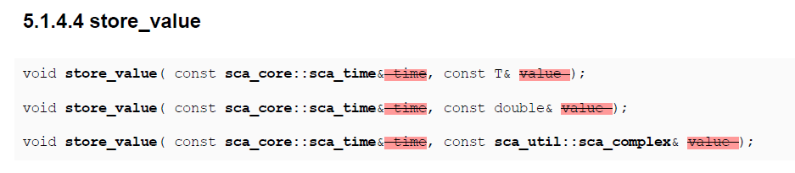
  - Added (green)
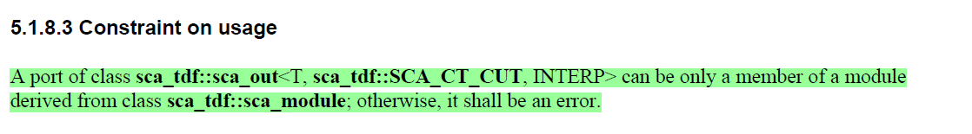
  - Changed (yellow)
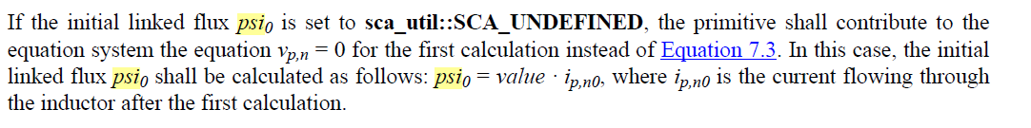
- Anticipated timeline for P1666.1 LRM
  - May 11, 2015: First draft available; review can start
  - June 1, 2015: Second draft planned; all change requests implemented; 2nd round review; Freeze technical content/update
  - July 2015: Finalize IEEE typographical updates;
  - August 2015: P1666.1 working group ballot to ratify the standard
  - Sept/Oct 2015: Transfer document to IEEE for formal balloting process
- Discussion:
  - Joe mentions that the formal ballot is done in IEEE-SA, and that the WG needs to ratify and transfer the standard beforehand.
  - The current draft document does not yet fully comply to the IEEE stylesheet manual. Martin will work with Joe to resolve this.
  - All members are requested to review the sections highlighted in red/green/yellow. More details can be found in the change request document.
  - The open items need a formal definition, which will be proposed by Martin via the mailing reflector. Everyone is encouraged to give his feedback.
7. AOB
- Attendance tracking page on Twiki:
  - http://www.eda.org/twiki/bin/view.cgi/P16661/AttendanceTracking
  - Please let me know if your company attendance is not tracked correctly
- AOB of the attendees
  - Joe: Next meeting on June 8 collides with DAC conference. Proposed to move the meeting to June 1. The team agrees.

8. Next meeting
- June 1, 2015 at 17:00h CET.
http://www.eda.org/twiki/bin/view.cgi/P16661/June1%2c2015
- Invite will follow.

9. Adjournment
Meeting adjourned at 17.51h CET.

